

EXPERIMENT REPORT

|  |  |
| --- | --- |
| **Experiment Name** | BJT and MOS AMPLIFIER CIRCUITS |
| **Asistant Name** | Mehmet ATASOYLU |
| **Student**  **(Name / Number / Department)** | Ali Han POLAT / 040110207  /Electronics and Communication Engineering |
| **Group Number and Experiment Date** | D14-5.12.2014 |

|  |  |  |
| --- | --- | --- |
| **Report Grade** | **Delivery Date** | **Acception Date** |
|  | 12.12.2014 |  |

EXPERIMENT 3

**BJT and MOS AMPLIFIER CIRCUITS**

**The Purpose of This Experiment:**

Most commonly used small-signal amplifiers are the common emitter configuration for BJT amplifiers and common source configuration for MOS amplifiers. In this experiment we had learned how to measure voltage gain of amplifier circuits and seen the differences when emitter/source shunt capacitor is removed.

We have measured the terminal voltages of BJT and MOS amplifiers. (VC, VB, VE, VG, VD, VS, VO)

Plots of these voltages and voltage gain are drawn with SPICE and given below.

**With Bypass Capacitor:**

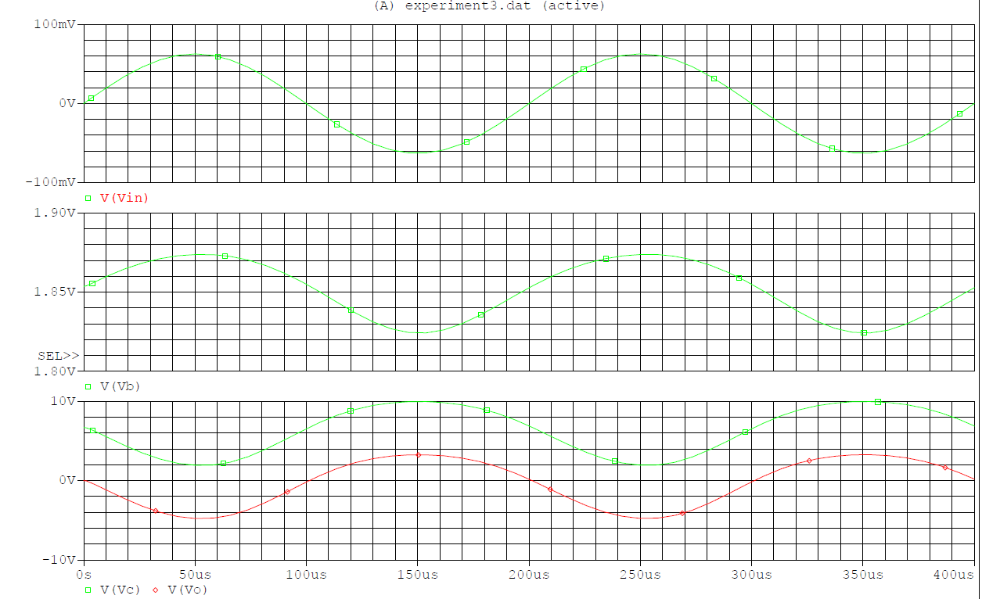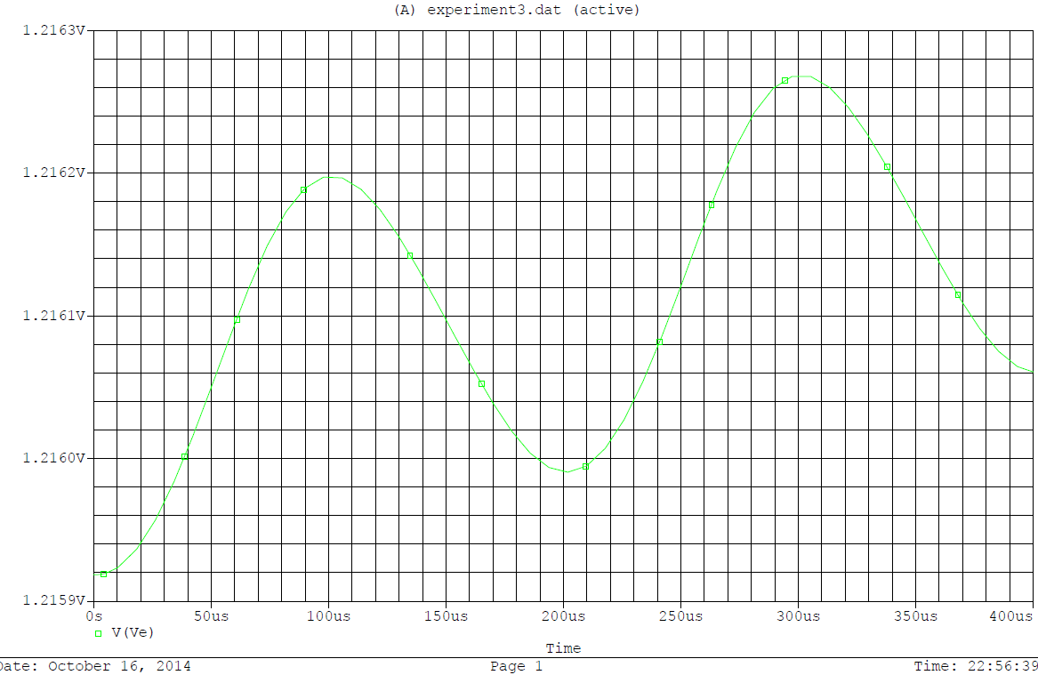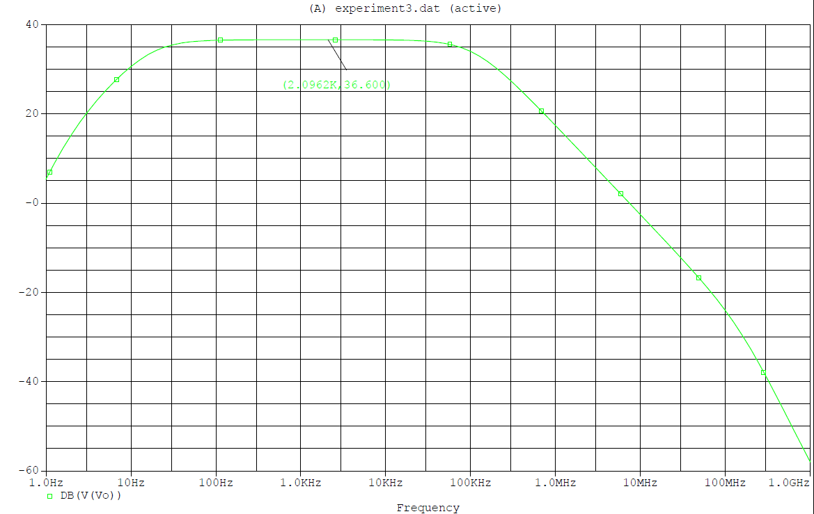

GAIN = 36,6dB = 67,60 V/V

**Without Bypass Capacitor:**

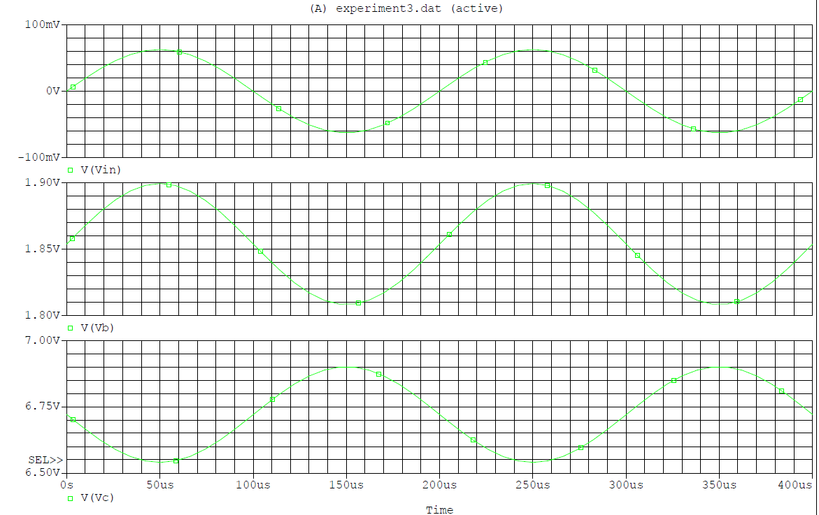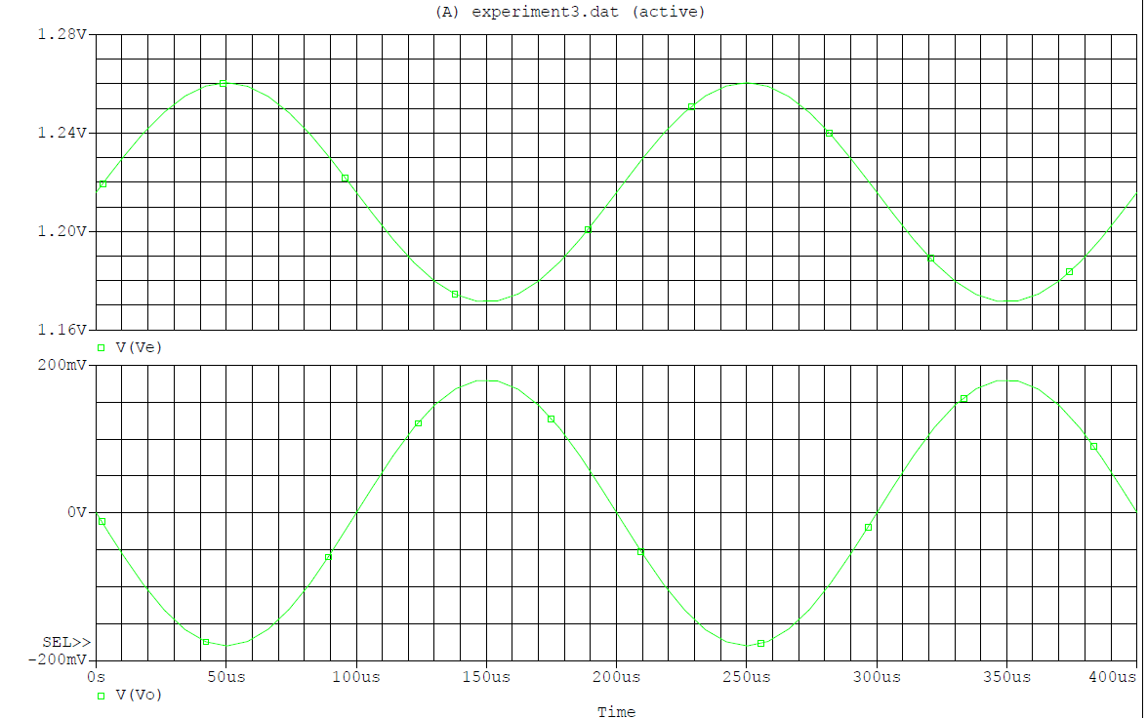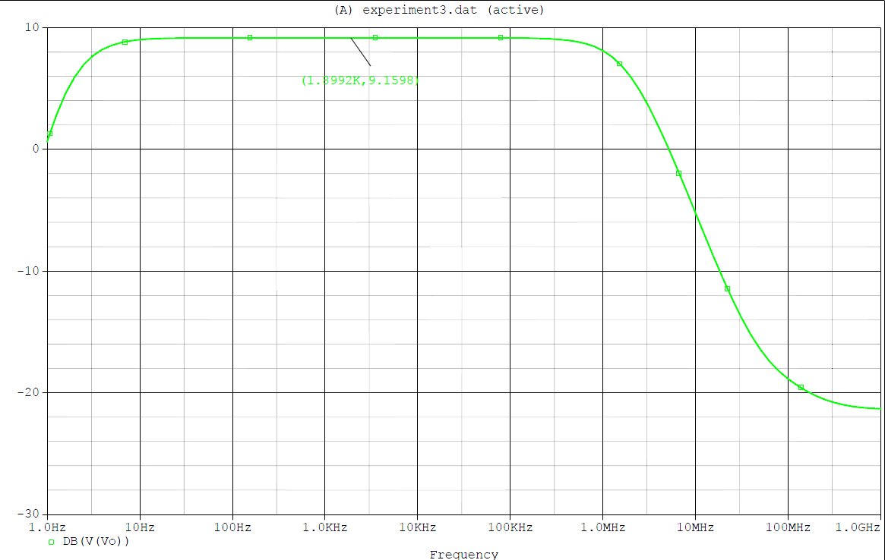

GAIN = 9,15dB = 2,86 V/V